# **ASP.NET**

Dependency injection concept

It start from main method 🡪 HostBuilder 🡪 StartUp 🡪 startup have a two method 🡪 Configuration service & configuration 🡪 in configuration, declare specific own pipeline or create pipeline by use “USE” keyword.

IIS Express 🡺 It is a light weight server.

IIS 🡺 It is Heavy weight compare to IIS Express.

**MVC (Model View Controller):**

ASP.NET Core MVC is a rich framework for building web apps and APIs using the Model-View-Controller design pattern.

Create asp.net web(model,view,controller)🡺 to start create project.

Then create new repositary to store code into GitHub and create programing what we want then press F5 to run through the browser directly.

**Controller:**

The controller handles and responds to user input and interaction.

Localhost:2353/helloworld

Controllers folder – HelloworldController

[---It is default way to display the output

Localhost : 2353/{controller=Home}/{action=Index}/{id?}---]

**Ex:**

app.UseEndpoints(endpoints =>

{

endpoints.MapControllerRoute(

name: "default",

pattern: "{controller=Home}/{action=Index}/{id?}");

});

**Model:**

Business logic should be encapsulated in the model, along with any implementation logic for persisting the state of the application.

**View:**

A view is a component involved in the application user interface. This displays the required data or collects data from users.

**Advantages of MVC Framework:**

* Separation of concern means we divide the application Model, Control  and View.
* We can easily maintain our application because of separation of concern.
* In the same time we can split many developers work at a time. It  will not affects  one developer work to another developer work.
* It supports TTD (test-driven development). We can create an application with unit test. We can write won test case.
* Latest version of MVC Support default responsive web site and mobile templates.
* We can create own view engine. It is syntax is very easy compare to traditional view engine.

**View Data:**

1. ViewData transfers data from the Controller to View, not vice-versa.
2. ViewData is a dictionary type.
3. ViewData's life only lasts during the current HTTP request. ViewData values will be cleared if redirection occurs.
4. ViewData value must be typecast to an appropriate type before using it.
5. ViewBag internally inserts data into ViewData dictionary. So the key of ViewData and property of ViewBag must **NOT** match.

**ViewBag:**

ViewBag only transfers data from controller to view, not visa-versa. ViewBag values will be null if redirection occurs.

**ActionFilters:**

Action filter executes before and after an action method executes. Action filter attributes can be applied to an individual action method or to a controller. When an action filter is applied to a controller, it will be applied to all the controller's action methods.

**RedirectToAction:**

In HomeController.cs rediect the particular method to another use key word “**RedirectToAction”**

**Synatx:** *return RedirectToAction("Index", "Department", null);*

In Layout.cs add navigation item into the list

<li class="nav-item">

<a class="nav-link text-dark" **asp-area**="" **asp-controller**="Department" **asp-action**="Index">Department</a>

</li>

Name of the Middelware – Static Files, Self Contain Mode and Portable Mode.

When sharing the .net cor we want .net standard, Internal Webserver is Castreol and Exteranal web server is IISExpress and IIS

**Startup.cs 🡪 configure service**

**Transient** – Each request have create a new obj. same or diff client took request to asp.net core app. Obj create based on req

Syntax: services.Add(new ServiceDescriptor(typeof(ILog),new MyConsoleLogger()));

Eg.. News Article

**Scoped** – Every client create each one obj. Not create new in each req. Obj create based on client

Syntax: services.Add(new ServiceDescriptor(typeof(ILog), typeof(MyConsoleLogger), ServiceLifetime.Transient));

Eg.. Banking Application, Amazon, G-Mail

**Singleton** – Only one obj is create even so many no of client req. Helper Class

Eg.. Obj Reuseability

Syntax: services.Add(newServiceDescriptor(typeof(ILog),typeof(MyConsoleLogger), ServiceLifetime.Scoped));

**Entity FrameWork:**

Entity Framework Core is a **lightweight, extensible, open source and cross-platform version** of the popular Entity Framework data access technology.

**Advantages of Entity Framework**

* It provides auto generated code
* It reduce development time
* It reduce development cost
* It enables developers to visually design models and mapping of database
* It provides capability of programming a conceptual model.
* It provides unique syntax ([LINQ](https://cybarlab.com/linq) / Yoda) for all object queries whether it is database or not
* It allow multiple conceptual models to mapped to a single storage schema
* It’s easy to map business objects (with drag & drop tables).

LINQ:

LINQ (Language Integrated Query) is uniform query syntax in C# and VB.NET to retrieve data from different sources and formats. It is integrated in C# or VB, thereby eliminating the mismatch between programming languages and databases, as well as providing a single querying interface for different types of data sources.

LINQ queries return results as objects.

**Dependencies Injection**: It is inject class to program to avoid maintainig problem.

**GET**: To get the value and check database like whether it is present or not Then display the page

**POST**: To store or send the value on database in backend process.

In the code have Update delete and create also then SaveChanges() method to change in database.

**What are the main HTTP verbs?**

The primary or most-commonly-used HTTP verbs are **POST, GET, PUT, PATCH, and DELETE**. These correspond to create, read, update, and delete (or CRUD) operations, respectively.

* **HTTP GET** – Read Operatio
* **HTTP POST** – Create Operation
* **HTTP PUT** – Update Operation
* **HTTP DELETE** – Delete Operation

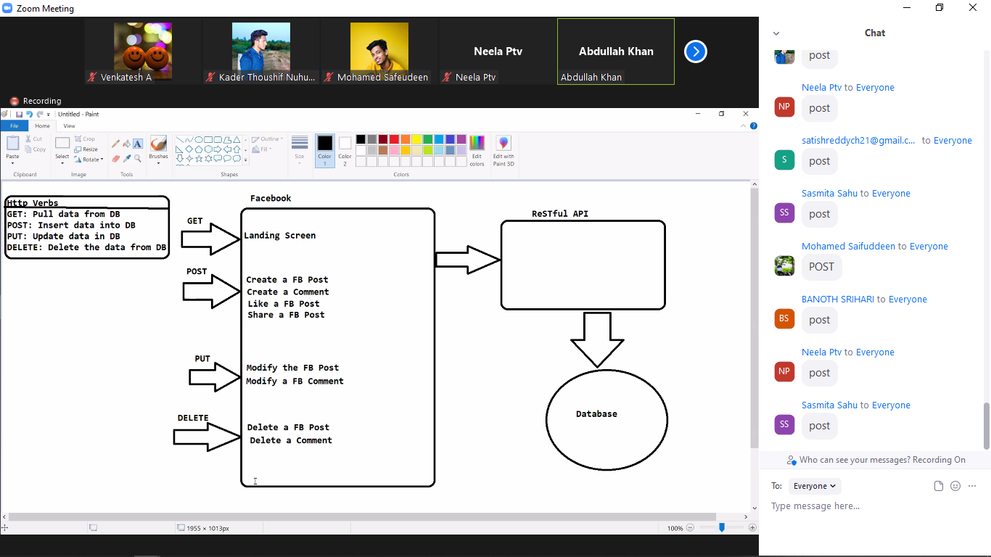

**API:**

Its return JSON. because all programming language known json type value.

**Docker:**

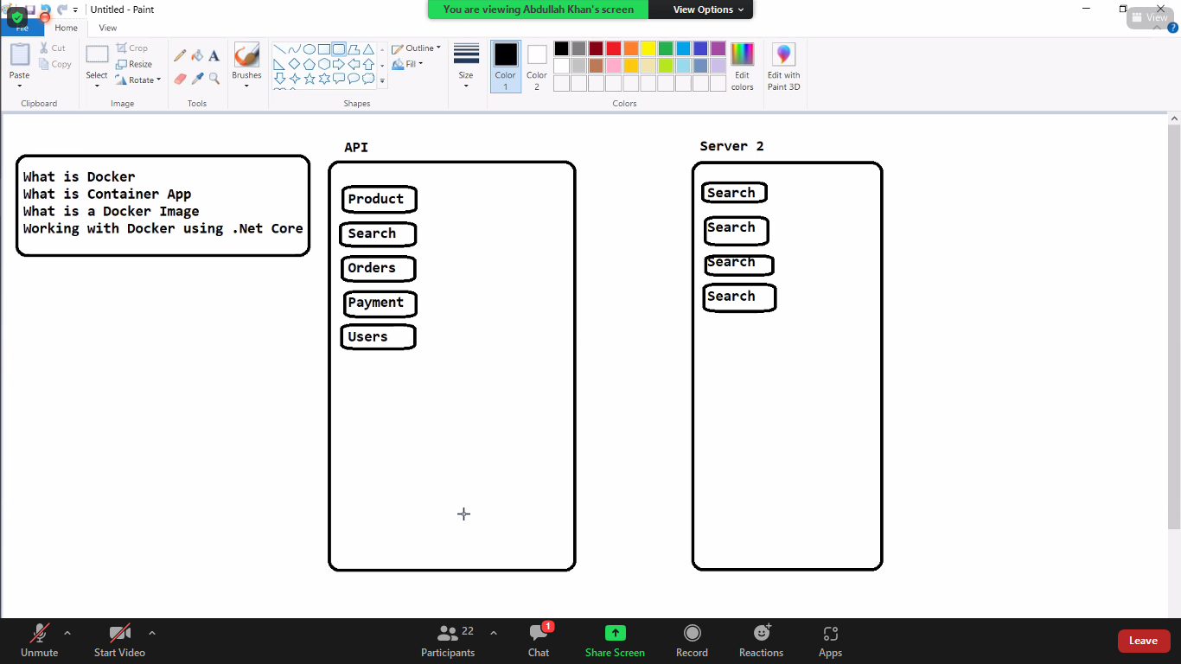

Docker is an open-source centralized platform designed to create, deploy, and run applications. Docker uses container on the host's operating system to run applications.

**Docker-Image:**

The docker image is the read-only file which cannot be modified once it's created, but we can delete the image from docker.